**Bank Balance and Dispensing System**

1. **URL**: [**http://localhost:9090**](http://localhost:9090)
2. **Home Page**

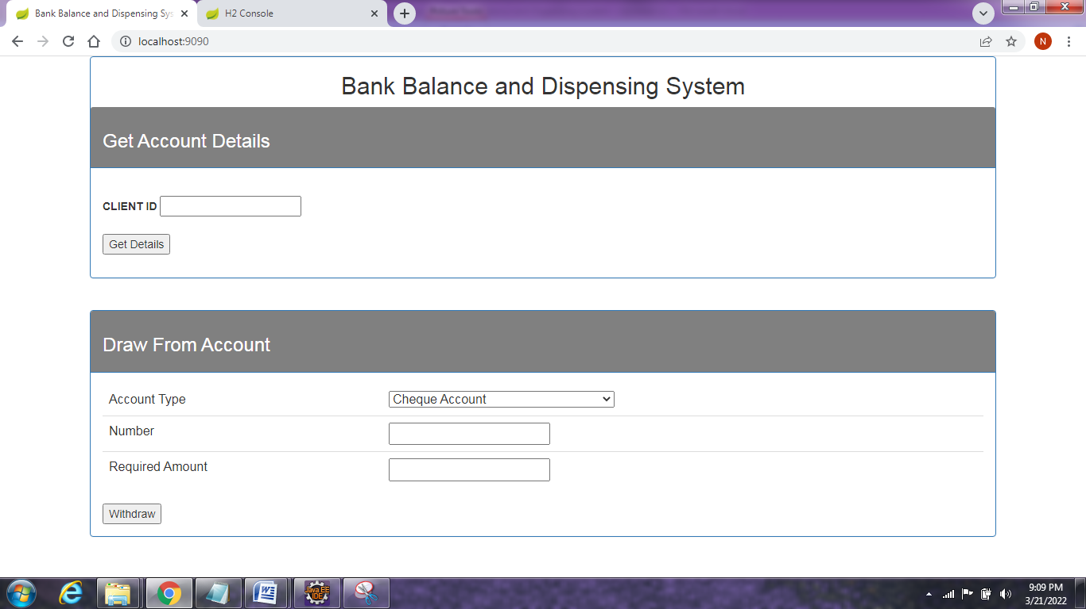

1. **Display transactional accounts with balances**

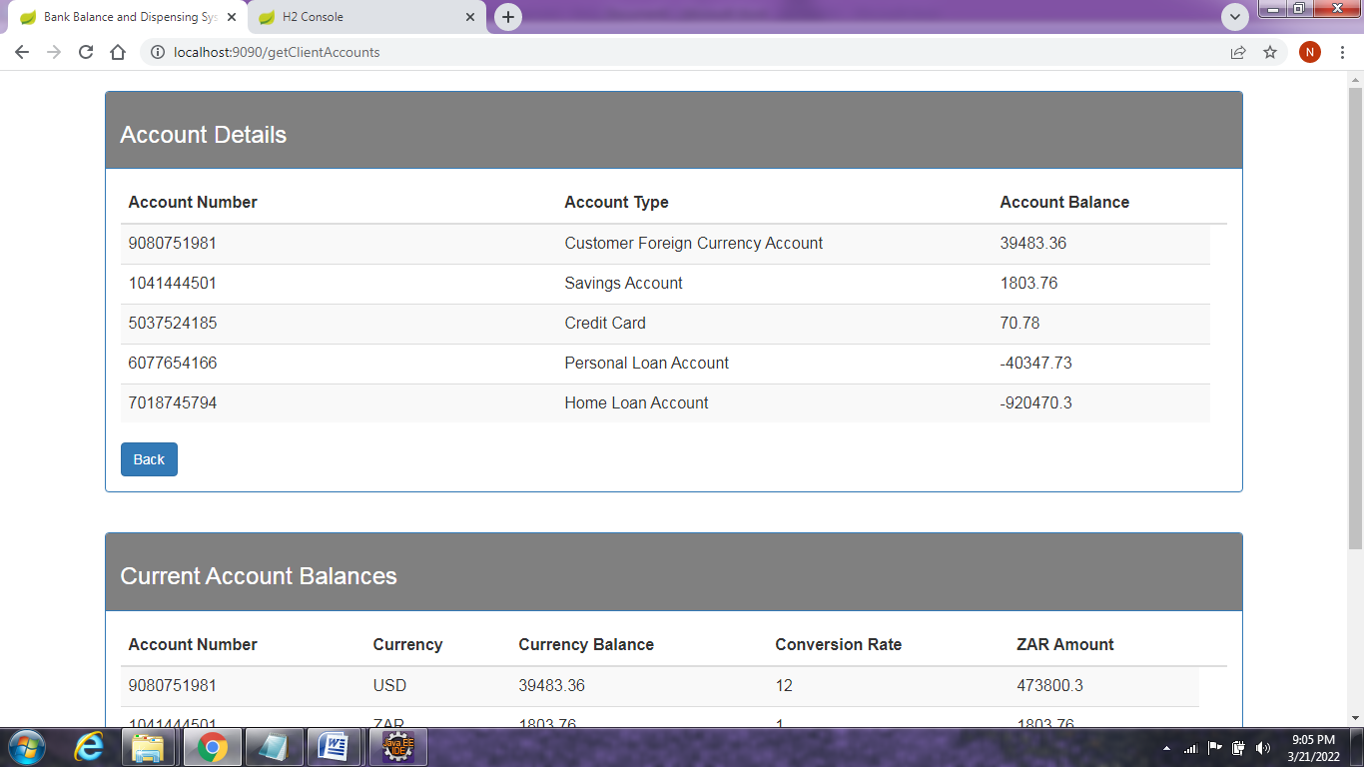

1. **Display currency accounts with converted Rand values**

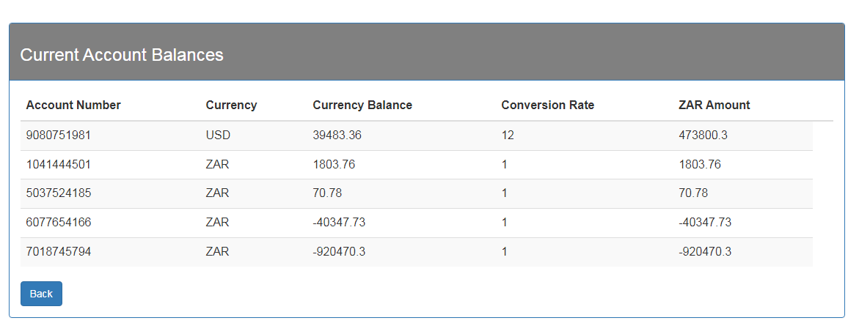

1. **Withdraw cash**

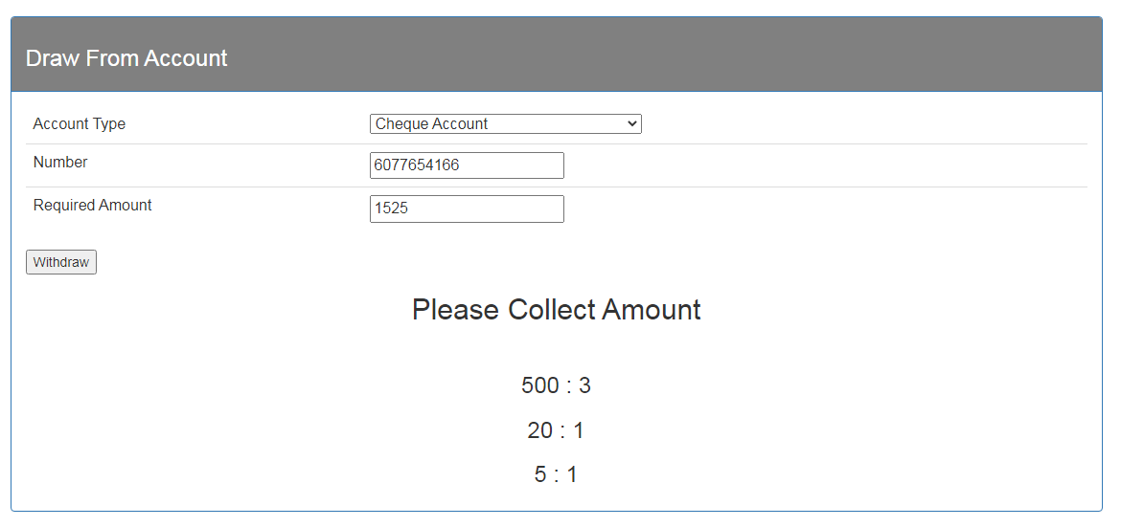

**H2 DB Console:**

